CANCER DETECTION USING COMPUTER VISION AND FAST AI

Dissertation submitted in part fulfilment of the requirements

for the degree of

**[MSc in DATA ANALYTICS]**

at Dublin Business School

MSc in Data Analytics 2019-2020

# DECLARATION:

I, the undersigned, hereby declare that this research thesis is my own original work and that all sources have been accurately reported and acknowledged, and that this document has not been previously, in its entirely or in part, submitted at any university in order to obtain academic qualifications.

Vedant Patil 06/01/2020

SIGNATURE DATE

# ACKNOWLEDGMENTS:

It is a pleasure for me to thank every one of the individuals who have contributed for this and made it conceivable. Firstly, I want to offer my genuine thanks towards my supervisor Basel Megableh for sharing his vision, giving me the important heading from the beginning of the exploration to the last stage. He quietly tuned in to every one of my questions and comprehended it tranquilly.

I would need to thank every one of the people who direct and by suggestion helped me groom my knowledge and showed me over the range of my lord's investigation. Overall, I would want to thank my folks and give my sincere gratefulness for all the assistance and reassurance they have given me during the whole ace's voyage.

# **ABSTRACT**:

*Over the previous decade, sensational increments in computational force and improvement in picture examination calculations have permitted the improvement of incredible machines helped investigate ways to deal with radiological information. With the ongoing appearance of entire slide computerized scanners, tissue histopathology slides would now be able to be digitized and put away in computerized picture structure. Cancer growth has been described as a heterogeneous disease comprising of various subtypes. The early diagnosis and prognosis of an accurate cancer type have become a top priority in the field of oncology, as it can encourage the consequent clinical treatments of patients. The significance of detecting cancer in patients into high or low risk groups has driven many research groups, from the biomedical and the bioinformatics field, to think about the utilization of machine learning techniques. In this way, these methods have been used as a plan to show the movement and treatment of harmful conditions. Furthermore, the capacity of Deep Learning methods to identify key highlights from complex datasets uncovers their significance. An assortment of these methods, including Deep Neural networks such as Artificial Neural Networks (ANNs), Convolutional Neural Network (CNN),have been generally applied in cancer research for the advancement of predictive models, image processing and bringing about powerful and exact accuracy. Even though it is apparent that the utilization of ML techniques can improve our comprehension of cancer growth movement, a suitable degree of approval is required all together for these strategies to be considered in the ordinary clinical practice. This research presents a survey of ongoing Deep Neural Network approaches utilized in the displaying of cancer progression. The prescient models talked about here depend on different administered ML procedures just as on various information highlights and information tests. Given the developing pattern on the utilization of neural network strategies in cancer research, this proposal presents latest productions that utilize these procedures as a plan to demonstrate disease hazard on patient results.*

*Keywords: Convolutional neural network (CNN), Computer vision, Fastai, Machine Learning (ML)*

Table of Contents

DECLARATION: 2

ACKNOWLEDGMENTS: 3

ABSTRACT: 4

Chapter 1: INTRODUCTION 6

Chapter 2: LITERATURE REVIEW 7

Chapter 3: DATASET USED 12

Chapter 4: METHODOLOGY 13

4.1 CONVOLUTIONAL NEURAL NETWORK 13

4.2 Elements of CNN: (KeonYong Lee, April 2019) 13

4.2.1 Convolution: 13

4.2.2 Stride: 14

4.2.3 Padding: 14

4.3 Edge Detection: 14

4.4 Pooling: 15

4.4.1 Average Pooling: 15

4.4.2 Max Pooling: 16

4.5 RELU FUNCTION: (RECTIFIED LINEAR UNIT) 16

4.5.1 DYING RELU: 17

4.6 ADAPTIVE LEARNING RATES: 17

4.7 Using Tensorflow 17

Chapter 5 What is computer vision? 18

Chapter 6 Image Processing 19

Chapter 7 PROPOSED METHOD 20

7.1 Image processing 20

7.2 Feature Extraction 20

7.3 Classification 21

Chapter 8 What is Fastai? 22

Chapter 9 Model Implementation 23

9.1 CODE EXECUTED BY: 23

9.1.1 Importing required libraries: 23

9.1.2 Reading the entire image data: 23

9.1.3 Balanced classes are achieved by testing the image data and splitting into train and validation: 23

9.1.4 Fragmenting the data by creating 2 different dictionaries: 23

9.1.5 Data augmentation and conversion into tensors: 23

9.1.6 Move the trained, tested and validated data to the suitable folders: 23

9.1.7 Model compilation and training: 24

Chapter 10 CONCLUSION 25

**Table of Figures**

Figure 4. 1 14

Figure 4. 2 14

Figure 4. 3 15

Figure 4. 4 15

Figure 4. 5 17

Figure 4. 6 18

Figure 5 1: Computer Vision (Sorokina, 2017) 19

FIgure 6 1 20

Figure 7 1 21

Figure 9 1 25

# Chapter 1: INTRODUCTION

Nowadays, threatening development is a colossal general medicinal issue the world over. As demonstrated by the International Agency for Research on Cancer (IARC), some part of the World Health Association (WHO), there were 8.2 million passing’s realized by harmful development in 2012 and 27 million of new examples of this ailment are required to occur until 2030. Infinitesimal examination of hematoxylin and eosin (H&E) recolored segments has been the reason for disease finding and evaluating for the past century. Conventions for the total workup of biopsies or resected tissue examples, including minute examination, exist for a considerable lot of the most well-known cancer types (for example lung, breast, prostate). Utilization of these conventions has prompted solid prognostic and broadly utilized reviewing procedures (for example the Gleason evaluating framework). Because of the ascent in cancer occurrence and patient-explicit treatment choices, finding and reviewing of disease has gotten progressively unpredictable. Pathologists these days need to go over an enormous number of slides, regularly including extra immunohistochemical stains, to go to a total conclusion. Also, there is an expansion in the measure of quantitative parameters pathologists need to separate for generally utilized reviewing frameworks (for example lengths, surface regions, mitotic checks). Because of these troubles, investigation conventions have been adjusted and tweaked to offer the best harmony between prognostic force and attainability in day by day clinical daily practice. (Litjens, G., Sánchez, C., Timofeeva, N.  (2016). The ongoing presentation of entire slide checking frameworks offers a chance to evaluate and improve histopathologic methods. These frameworks digitize glass slides with recolored tissue areas at high goals. Computerized whole slide pictures (WSI) permit the use of picture investigation strategies to help pathologists in the assessment and measurement of slides. One such technique which has picked up unmistakable quality over the most recent five years in different fields is 'deep learning'. While 'deep learning' can't be viewed as a solitary procedure, it can generally be depicted as the use of multi-layered artificial neural networks to a wide scope of issues, from discourse acknowledgment to picture examination. Lately, 'deep learning' procedures have immediately become the best in class in computer vision. A particular neural system subtype (convolutional neural networks); CNN has become de facto standard in image recognition and is moving toward human execution in various tasks. These frameworks work by gaining important features legitimately from large picture databases (typically millions of pictures). This is as opposed to increasingly customary example acknowledgment methods, which emphatically depend on physically created quantitative feature extractors. Some underlying work has been distributed in the course of the most recent five years talking about the use of 'deep learning' techniques to microscopic and histopathologic pictures. Ciresan et al. were the first to apply convolutional neural systems to the errand of mitosis counting for primary breast malignancy grading. Moreover, in an alternate distribution, they indicated the pertinence of patch driven convolutional neural networks to division tasks. Wang et al. later extended the work on mitosis discovery by consolidating hand-made highlights and convolutional neural networks. Different utilizations of convolutional systems incorporate essential breast cancer detection, glioma grading and epithelium and stroma segmentation. Last, Su et al. utilized another 'deep learning' strategy, called stacked denoising auto-encoders to perform cell detection and segmentation in lung cancer and cerebrum tumors. This study explores the general appropriateness of CNNs to improve the productivity of cancer diagnosis in histological pictures by applying it to neural networks: the identification of prostate cancer in biopsy examples and the discovery of cancer tissues in lymph nodes. For example, Kowal et al. consider and test different estimations for centres division, where the cases are designated either affable or unsafe on a dataset of 500 pictures, and report accuracy's running from 96% to 100%.

# Chapter 2: LITERATURE REVIEW

Histopathological cancer is one of the main sources of death for ladies all around. As indicated by the World Health Organization (WHO), the quantity of malignancy cases expected in 2025 will be 19.3 million cases. In Egypt, malignant growth is an expanding issue and particularly bosom disease. Mammography is as of now one of the significant strategies to recognize bosom malignant growth early. The attractive reverberation imaging (MRI) is the most alluring option in contrast to mammogram. In any case, the MRI test is done when the radiologists need to affirm about the presence of the tumor. The downside of the MRI is that the patient could build up an unfavorably susceptible response to the differentiating operator, or that a skin disease could create at the spot of infusion. It may cause claustrophobia. Masses and microcalcifcations (MCs) are two significant early indications of the malady. There are different markers of bosom malignant growth, for example, compositional mutilation (Bozek et al., 2009) yet these are less noteworthy.

During the previous years, different commitments have been made in writing with respect to the utilization of example acknowledgment procedures for breast cancer growth finding in tissue level. Rejani and his gathering proposed an example acknowledgment system to arrange the bosom tumor (Rejani and Selvi 2009). They utilized the image segmentation to fragment the breast tissue comparing to the tumor what's more, utilized the discrete wavelet change (DWT) as an element extraction strategy to extricate different highlights from the portioned pictures. At that point they additionally utilized SVM classifier to group the bosom tissue comparing to the highlights and accomplished a precision of 88.75%. Martin and his gathering proposed the strategy for recognition of mass on digitized mammograms (Martins et al. 2009). They utilized K-implies grouping calculation for picture division and dim level co-event network to portray and dissect the surface of divided structures in the picture. The characterization of these structures was accomplished through Support Vector Machines, which separate them into two gatherings; utilizing shape and surface descriptors: masses and non-masses. The characterization exactness acquired from that technique was 85%. Karabatak and his gathering proposed a programmed determination-based example acknowledgment framework for distinguishing breast cancer dependent on the affiliation rules (AR) and Artificial neural system (ANN) (Karabatak and Ince 2009). In that review, they utilized AR technique for decreasing the element of breast disease database and ANN for astute characterization. The proposed framework for example the mix of Artificial Intelligence and Artificial neural network, execution was contrasted and just ANN model. The measurement of info highlight space was diminished from nine to four by utilizing AR.

In the testing stage, they utilize Wisconsin breast cancer diagnosis (WBCD) database using adaptive neuro-fuzzy inference system (ANFIS) (Fatimaand Amine 2012) The correct classification rate obtained from that AR + ANN system was 95.6%. Jele and his group proposed a framework for automatic malignancy grading of the fine needle aspiration biopsy tissue (Jele et al. 2008).  They used an SVM classifier to assign a malignancy grade based on pre extracted features, with accuracy up to 94.24%. Arodz and his group proposed the Pattern recognition system for automatic detection of suspicious looking anomalies in mammograms (Arodź et al. 2005). They utilized adaboost calculation based classifier and accomplished an exactness of 90%.Brook and his gathering proposed a technique for Breast Cancer Diagnosis from Biopsy Images utilizing SVM (Brook et al. 2006). They applied multi-class SVM on nonexclusive component vectors to accomplish a high acknowledgment rate. Fatima and his gathering utilized a methodology for arranging the bosom malignancy from Wisconsin bosom malignancy finding (WBCD) database utilizing versatile neuro-fluffy induction framework (ANFIS) (Fatima also, Amine 2012). By utilizing the ANFIS classifier they were accomplished an exactness of 98.25 % in tissue level. Mousa and his gathering proposed an example acknowledgment strategy, to characterize masses for small scale calcification and strange seriousness, for example, considerate or dangerous from mammographic picture (Mousa et al. 2005). They utilized wavelet examination as a component extraction method and fluffy Neuro as a classifier to accomplish a superior order rate. Niwas and his gathering proposed the example acknowledgment task; by considering Color Wavelet Features as highlight extraction method from fragmented histopathology picture (Issac Niwas et al. 2012). They utilized SVM classifier which gives an exactness of 98.3%. Akay proposed another example acknowledgment technique by considering SVM classifier to order favorable and threatening masses (Akay 2009). They utilized WBCD breast cancer database and accomplished a precision of 98%. Shi and his gathering proposed another system for identification and characterization of masses from bosom ultrasound pictures. They utilized textural highlights, fractal includes as highlight extraction strategies and SVM, fluffy help vector machine (FSVM) as the classifiers, to characterize the kind and threatening masses (Shi et al. 2010).After order, they were accomplished a order exactness of 96.4% for FSVM classifier. Schaefer and his gathering proposed an example acknowledgment strategy, by thinking about fundamental measurable highlights, histogram highlights, cross cooccurrence framework highlights and shared data based highlights as the component extraction technique what's more, Fuzzy guideline based classifiers as characterization strategy to group the generous and harmful tumor types from the thermogram pictures (Schaefer et al. 2009). They accomplished an order pace of 79.53% with the assistance of 14 parcels based fluffy guideline classifier.

Malignant growth infection starts in the cells of the human body, which is produced by unusual division of those cells. There are two kinds of malignant growth, kind tumours are not harmful and dangerous tumours are malignant. Cancer growth causes deaths among ladies in numerous portions of the world is the most regularly analysed malignant growth among ladies between 40 what's more, 60 years old. Breast malignant growth can be maintained a strategic distance from and reparable if early discovery. In recent years, several techniques have been applied for tumour detection from various modalities, namely, X-ray mammography, CT-scan and magnetic resonance, ultrasound. Therapeutic pictures are significant job for object acknowledgment of the human organs. The reason for picture division is to segment pictures which have extraordinary trademark tissues into semantically interpretable districts, with the end goal that the attributes of every locale and concentrate intrigue objects. Image segmentation by numerical morphology is a system in light of the ideas of watershed change. Watershed change is an amazing asset for picture division. The goal of watershed transformation is to discover the watershed lines in topographic surface. The district that the watershed isolates called catchment basins.

In 2005, Zhao Yu-qian et.al, proposed a strategy to distinguish lungs CT restorative picture edge with salt and pepper commotion. Plainly show the calculation for restorative picture denoising and edge identification, and general morphological for example, morphological gradient operation and expansion build-up edge identifier. In 2008, K..Parvati et.al, proposed a strategy is in light of dim scale morphology. Execution edge recognition calculation incorporates work edge and marker-controlled watershed division. This examination shows the watershed by forefront markers and capacity the calculation to portion or concentrate wanted portions of any grey scale images. In 2011, Sharma proposed build up the strategy for image segmentation dependent on extraction of watershed lines from a topographic portrayal of information picture. This strategy has been tried distinctly on computerized mammogram picture to check if the majority distinguished are harmful or not. In 2011, J. Mehena actualized scientific morphological edge recognition calculation such as Sobel, Prewitt, Robert and morphological angle activity to identify medicinal MRI picture edge. In 2011, Wen-Feng et.al, Implemented another picture division method that joins watershed calculation and fluffy grouping calculations. This investigation show that the system gives additionally encouraging division result in examination with the customary watershed calculation by methods for a few mind apparitions furthermore, genuine data. In 2013,P.P.Acharjya et.al, examined another approach of watershed calculation utilizing Separation Transform is applied to Image segmentation. This paper concentrated on watershed calculation usage on three picture and finished up the new approach through the distinction in the PSNR and Entropy.

In 2013,N.R.Raajan et.al, actualized pictures gathered from database of MRI/CT. First are improved by utilizing Gabor channels to dissect the visual properties of malignancy pictures. At that point improved picture is then portioned utilizing marker-controlled watershed division at that point separated the highlights from the fragmented picture. This venture shows the watershed by closer view markers can portion genuine pictures. In 2013, Hemant Tulsani et.al, displayed an approach for tallying diverse platelets during blood smear test by division utilizing morphological watershed change .this paper show a very comparative outcome for all the pictures. Be that as it may, this technique is just able of little over lab in the picture however fruitless for a major over lab.

CNNs are feed-forward, back-engendering neural systems with an extraordinary engineering enlivened by the human visual framework that have made progress in picture, video, sound, and artifcial insight applications. First proposed by Fukushima in the mid 1980s and enhanced by LeCun et al. during the 1990s, CNN has been utilized in different applications, including penmanship classifcation, picture classifcation, object identifcation, and the assurance of mitotic cells. Not at all like other profound learning calculations that acknowledge vectorial input, the CNN structure utilizes two-dimensional info information. It comprises of convolution and subsampling or pooling layers; in the previous, as per the kind of convolution bit, diverse element maps can be separated. It is conceivable to utilize similar parts in every convolution layer or contrastingly estimated bits. Nuh Hatipoglu, Gokhan Bilgin, Feb 2017

The accomplished discovery rate was 96% for ANN and 98% for SVM (Ragab, Sharkas and Al-sharkawy, 2013). Cristina Juarez, Ponomaryov and Luis Sanchez (2006) applied the capacities db2, db4, db8 and db16 of the Daubechies wavelets family to recognize MCs. The accomplished rate was near 80% precision. Al-Sharkawy, Sharkas and Ragab (2012) identified mass injuries utilizing the DWT and SVM, the rate accomplished was 92%. Suzuki et al. (2016) utilized the profound convolutional neural system (DCNN) for mass discovery. This investigation presented the exchange learning in the DCNN. The affectability accomplished when separating between mass and typical injuries was 89.9% utilizing the advanced database for screening mammography (DDSM) (Heath et al., 2001). Their investigation was the principal show for the DCNN mammographic CAD applications. Dhungel, Carneiro and Bradley (2015) utilized the multi-scale conviction arrange in distinguishing masses in mammograms. The affectability accomplished was 85%–90% utilizing the INbreast and DDSM-BCRP datasets, separately. The fundamental disadvantage of Dhungel, Carneiro and Bradley (2015) is the constrained size of the preparation set. The quantity of preparing and testing utilized were 39 and 40 cases, separately. Wichakam et al. (2016) utilized the DCNN and SVM. The affectability accomplished was 98.44% utilizing the INbreast dataset. Arbach, Stolpen and Reinhardt (2004) grouped the MRI bosom injuries utilizing back engendering neural system (BPNN). They found that the zone under the collector working qualities (ROC) bend was 0.913. Sahiner et al. (1996) utilized the convolutional neural system (CNN) to group ordinary and anomalous mass bosom injuries. Regarding the writing, this original copy exhibits another CAD framework to characterize benevolent and dangerous mass injuries from mammogram tests utilizing profound learning based SVM. The fundamental commitment is that two division approaches are utilized: (1) portioning the ROI physically and (2) utilizing an edge and area based systems. The DCNN is utilized as the component extraction instrument while the last completely associated (fc) layer of the DCNN is associated with SVM to acquire better arrangement results. Moreover, the investigations are tried on two datasets; (1) the DDSM and (2) the Curated Breast Imaging Subset of DDSM (CBIS-DDSM) (Lee et al., 2017). Picture upgrade is preparing the mammogram pictures to build differentiate and stifle clamor so as to help radiologists in recognizing the irregularities.

DCNN has made progress in picture arrangement issues including picture examination as in (Han et al., 2015; Zabalza et al., 2016). A convolutional neural system (CNN) comprises of numerous trainable stages stacked over one another, trailed by a managed classifier what's more, arrangements of clusters named highlight maps (LeCun, Kavukcuoglu and Farabet, 2010). There are three fundamental kinds of layers used to assemble CNN designs; (1) convolutional layer, (2) pooling layer, and (3) completely associated (fc) layer (Spanhol, 2016). There are numerous CNN structures, for example, CiFarNet (Krizhevsky, 2009; Roth et al., 2016), AlexNet (Krizhevsky, Sutskever and Hinton, 2012), GoogLeNet (Szegedy et al., 2015),the ResNet (Sun, 2016), VGG16, and VGG 19. Be that as it may, the most generally utilized designs are the AlexNet, CiFarNet, and the Inception v1 (GoogleNet). The AlexNet design accomplished fundamentally better execution over the other profound learning strategies for ImageNet Large Scale Visual Recognition Challenge (ILSVRC) 2012. This achievement has restored the enthusiasm for CNNs in PC vision. AlexNet has five convolution layers, three pooling layers, and two completely associated layers with roughly 60 million free parameters (Krizhevsky, Sutskever and Hinton, 2012).

Alolfe et al. in 2009 utilized a FastAI and direct discriminant investigation to recognize kind and defame tumors on the MIAS database. Utilizing this methodology, they grouped 90% and 87.5% of considerate and harmful pictures effectively, separately.  Wang et al. in 2013 utilized the mammographies from 482 patients to analyze the correctnesses from an outrageous learning machine (ELM) and a SVM to arrange between pictures with what's more, without tumors. In the preprocessing stage a middle channel was utilized to diminish the clamor and the wavelet change of nearby modulus maxima related to the area developing calculation were utilized as edge division technique. At last, five textural highlights and five morphological highlights were separated from the subsequent picture and these were utilized at the grouping task. The ElM classifier shows preferred execution over the SVM classifier. Dheeba et al. in 2014 got an exactness of 93.67% ordering among ordinary and anomalous tissues with an improved neural system utilizing Particle Swarm Optimization. The analysis was done with their private database of mammograms and the order was finished with the Laws Texture Energy Measures extricated from a return for money invested of measurement 15 ˆ 15 pixels. Peng, Mayorga and Hussein in 2015 got an exactness of 96% utilizing a fake neural system to group the mammograms from MIAS database. They characterized three various classes to do the examination: typical, with nearness of an amiable tumor and with nearness of a censure tumor. A middle channel and the seeded district developing calculation were utilized to evacuate the commotion of the first pictures. At that point, they separated 16 highlights identified with the surface properties of the pictures and five of them were chosen. The include choice calculation, which depends on the harsh set hypothesis, was created by the creators. Mahersia, Boulehmi and Hamrouni in 2015 accomplished acknowledgment paces of 97.08% and 95.42% on the MIAS database utilizing a neural system with a Bayesian back propagation calculation and an ANFIS framework as classifiers, individually. The bosoms were characterized into two classifications: ordinary and malignant. The mammograms from this database were first improved, evacuating the clamor and subtleties that may meddle with the acknowledgment of the tumors. At that point a summed up Gaussian thickness model for wavelet coefficients was utilized as highlight extractor.

Ertosun and Rubin in 2015 utilized three distinct designs of CNNs to find masses in mammography pictures. They chose 2420 pictures from the DDSM dataset and partitioned these pictures into preparing, approval and test sets, containing 80%, 10% and 10% of the pictures,individually.  
They additionally utilized trimming, interpretation, pivot, flipping and scaling strategies to get an increased preparing set, all together to improve the speculation capacity of the framework. The analyze was separated into two phases: the first comprised in the arrangement of a mammography as containing or not masses and the second in the confinement of masses in the pictures. Arevalo et al. in 2015 got 86% of region under the Beneficiary Operating Characteristic (ROC) bend by ordering mammography mass injuries utilizing a CNN as highlight extractor and a SVM as classifier . The information to complete the test was the BCDR-F03 dataset, which is part of the BCDR database. This information was made by 736 pictures, 426 containing favorable mass sores and the rest  
containing dangerous sores. The information enlargement was accomplished by flipping and pivoting the pictures. What's more, the mammography pictures were standardized by the utilization of worldwide also, differentiate standardization. The CNN was prepared utilizing both dropout and max-standard regularization methods. Jiao et al. in 2015 got an exactness of 96.7% arranging the breast masses among benevolent and censure from the DDSM database utilizing a CNN as highlight extractor. The pictures were recently standardized also, brightened. Then again, the CNN was prepared with a subset of ImageNet  and the highlights to play out the order were removed from two unique layers of the CNN. Abdel-Zaher and Eldeib in 2015 built up a classifier utilizing the loads of a recently prepared profound conviction organize as the underlying parameters for a neural system with Liebenberg Marquardt learning capacity This model was tried on the Wisconsin Breast Cancer Dataset, getting a precision of 99.68%.

A great deal of intensive assessments on the BreaKHis dataset proposed shows that the CNN achieves favoured results over the best results got by the other AI models arranged with textural descriptors. The best execution, in any case, are gained by joining unmistakable CNNs using direct blend rules, for instance, Max, Product, and Sum, provoking an improvement in portrayal accuracy of 6% when appeared differently in relation to the tests revealed in.

(Filipczuk et al.) present a Breast Cancer assurance system subject to the examination of cytological pictures of fine needle biopsies, to isolate the photos as either pleasant or hurtful. Using four unmistakable classifiers arranged with a 25-dimensional incorporate vector, they report an introduction of 98% on 737 pictures. Zhang et al. propose a course approach with expulsion elective. In the fundamental level of the course, makers envision understanding the basic cases while the hard ones are sent to a second level where an undeniably flighty model game plan system is used. They assess the propose method on a database proposed by the Israel Institute of Technology, which is made out of 361 pictures and report outcomes of 97% of steadfast quality. In another work, comparative makers assess a troupe of one-class classifiers on a comparable database achieving an affirmation rate. The plausibility of depiction learning isn't new, yet it risen as of late as a sensible alternative in light of the appearance and headway of the Graphic Processing Units (GPUs) which are prepared for passing on high computational throughput at tolerably ease, achieved through their incredibly parallel designing. Among the different systems, the Convolutional Neural Network (CNN) exhibited by LeCun in, has been commonly used to achieve bleeding edge realizes different structure affirmation issues. By virtue of surface gathering it has not been unprecedented. Hafemann et al.have showed up, for pictures of little and normally obvious surface, that CNN can outflank standard textural descriptors. Other than looking over particular CNN models, we furthermore explore different systems to oversee significant standards surface pictures without changing the CNN building used for low-objectives pictures.

# Chapter 3: DATASET USED

There are various datasets which are available for histopathological stained images like Breast Cancer for breast (WDBC) cancer Wisconsin Original Data Set (UC Irvine Machine Learning Repository), MITOS- ATYPIA-14 and BreakHis. The researcher has utilized the HISTOPATHOLOGICAL CANCER DETECTION (To identify metastatic tissue in histopathologic scans of lymph node sections).

In this dataset, there are large number of small pathology images to classify. Files are named with an image id. The train_labels.csv file provides the ground truth for the images in the train folder. This proposal includes predicting the labels for the images in the test folder. A positive label indicates that the center 32x32px region of a patch contains at least one pixel of tumor tissue. Tumor tissue in the outer region of the patch does not influence the label. This outer region is provided to enable fully-convolutional models that do not use zero-padding, to ensure consistent behavior when applied to a whole-slide image.

PCam is a binary classification image dataset containing approximately 2,20,000 labeled low-resolution images of lymph node sections extracted from digital histopathological scans. Each image is labelled by trained pathologists for the presence of metastasised cancer.

The PatchCamelyon benchmark is a new and challenging image classification dataset. It consists of 2,20,000 patches(96x96 px) of clear and concise lymph nodes which are tumorous and non-tumorous.

# Chapter 4: METHODOLOGY

## 4.1 CONVOLUTIONAL NEURAL NETWORK

One of the most mainstream profound neural systems is the Convolutional Neural Network (CNN). It takes this name from scientific straight activity between grids called convolution. CNN have numerous layers; including convolutional layer, non-linearity layer, pooling layer and completely associated layer. The convolutional and completely associated layers have parameters however pooling and non-linearity layers don't have parameters. The CNN has a brilliant exhibition in AI issues. Extraordinarily the applications that manage picture information, for example, biggest picture characterization informational collection (Image Net), computer vision, and in regular language preparing (NLP) and the outcomes accomplished were astonishing.

The convolutional neural network, or CNN for short, is a specialized type of neural network model designed for working with two-dimensional image data, although they can be used with one-dimensional and three-dimensional data. (Jason Brownie, April 2019)

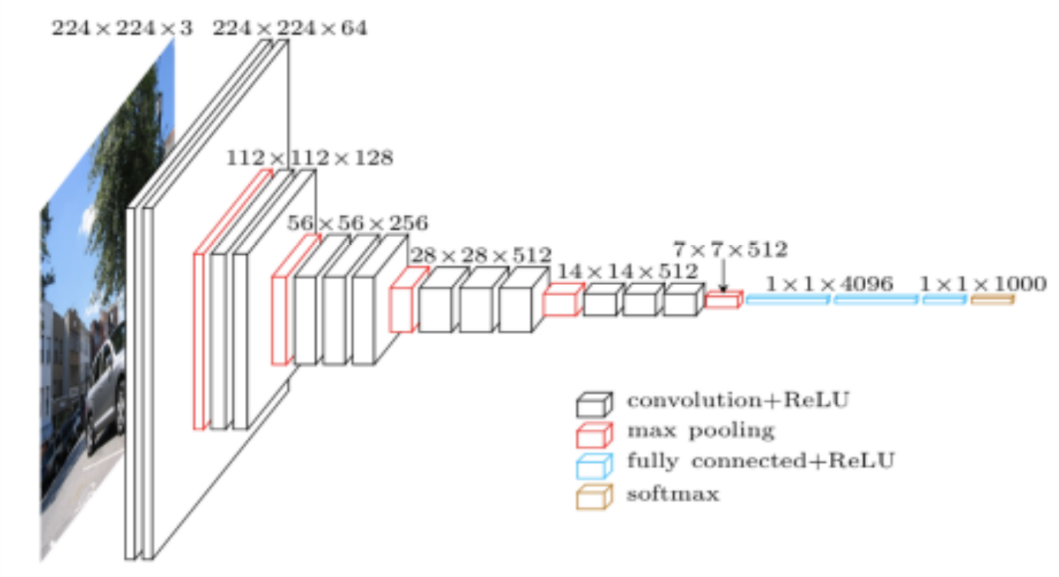

Figure 4. 1

## **4.2 Elements of CNN:** (KeonYong Lee, April 2019)

## 4.2.1 Convolution:

Central to the convolutional neural network is the convolutional layer that gives the network its name. This layer performs an operation called a “convolution“.

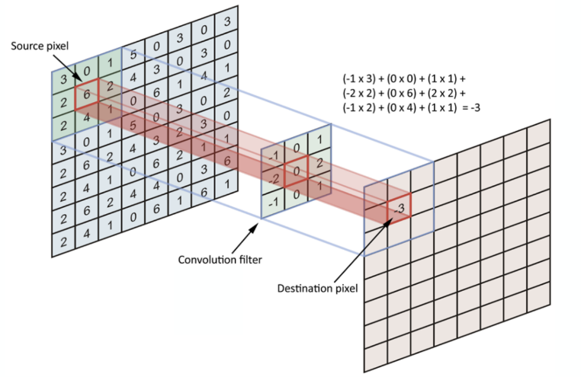

Figure 4. 2

## 4.2.2 Stride:

During strided convolution, the step size is larger than 1. This will shrink the output size even more because the kernel will make less stops as it moves around with bigger step size. With stride (s), the size of the output will be **⌊(n+2p-f)/s+1⌋**or**floor((n+2p-f)/s+1)**.

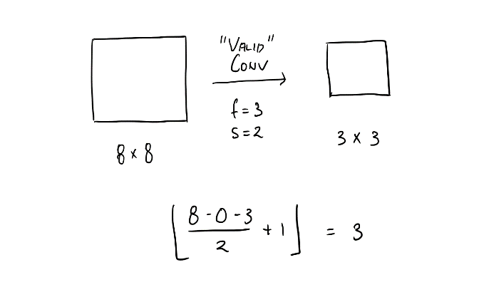

Figure 4. 3

## 4.2.3 Padding:

If the size of convolution kernel is larger than 1 x 1, the resulting matrix has to be smaller than the input. The shrink in size results in information loss. By padding the input, we can solve this problem. For the padded (p x p) convolution of an input (n x n) with a kernel (f x f), the size of output is **(n+2p-f+1) x (n+2p-f+1)**. There are two typical ways to pad an input. **“Valid”**convolution does no padding at all, and **“Same”**convolution uses padding so that the size of the output will stay the same as the size of the input.

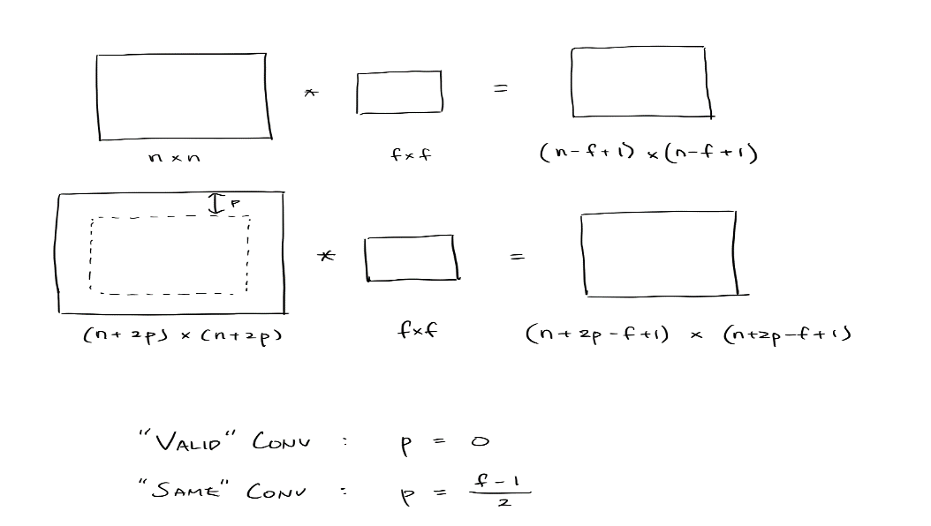

Figure 4. 4

## 4.3 Edge Detection:

A basic example of convolution operation is Edge detection process which is key element in convolution layers. A kernel(filter) will move around the input, and at stop during convolution. Confabulating about the output of the convolutional neural network which is matrix/vector with collection of numbers that are computed at each stop. A vertical edge detector is a piece with a lot of positive numbers at the left and a lot of negative numbers at the right. After convolution with a picture, high numbers in the subsequent lattice will reveal to us which part of the picture has abrupt changes in the pixel esteems from left to right. With the comparative rationale, a flat edge locator has a lot of positive numbers at the top and a lot of negative numbers at the base. The least difficult rendition of edge indicators utilize 1 and - 1, however progressively refined edge locators like Sobel edge and Scharr edge utilize one of a kind arrangements of numbers. In Deep Learning, we attempt to gain proficiency with those numbers by regarding them as parameters. Generally, edge recognition is found out by the prior layers of the system since edges are lower level component.

## 4.4 Pooling:

Pooling layers give a way to deal with down sampling feature maps by condensing the nearness of highlights in patches of the component map. Two popular pooling methods are average pooling and max pooling that outline the average presence of a component and the most enacted nearness of an element separately. Pooling is required to down sample the features if feature maps.

Down sampling can be cultivated with convolutional layers by changing the walk of the convolution over the image. An inexorably incredible and essential technique is to use a pooling layer.

A pooling layer is another layer included after the convolutional layer. Specifically, after a nonlinearity (for instance ReLU) has been applied to the segment maps yield by a convolutional layer; for example the layers in a model may look as seeks after:

o Input Image

o Convolutional Layer

o Nonlinearity

o Pooling Layer

The extension of a pooling layer after the convolutional layer is a normal model used for requesting layers inside a convolutional neural system that may be rehashed at any rate on various occasions in a given model.

• The pooling layer works upon every component map autonomously to make another arrangement of a similar number of pooled feature maps.

Pooling incorporates picking a pooling action, much like a channel to be applied to feature maps. The size of the pooling action or channel is more diminutive than the size of the segment map; expressly, it is frequently 2×2 pixels applied with a walk of 2 pixels.

• This infers the pooling layer will reliably diminish the size of each element map by a factor of 2, for instance every estimation is part, decreasing the number of pixels or characteristics in every segment manual for one quarter the size. For example, a pooling layer applied to a part guide of 6×6 (36 pixels) will bring about a yield pooled highlight guide of 3×3 (9 pixels).

The pooling activity is determined, as opposed to learned. Two normal capacities utilized in the pooling activity are:

## 4.4.1 Average Pooling:

On two-dimensional feature maps, pooling is commonly applied in 2×2 patches of the feature map with a stride of (2,2). Normal pooling includes ascertaining the average for each fix of the feature map. This implies each 2×2 square of the feature map is down sampled to the average value in the square.

## 4.4.2 Max Pooling:

Maximum pooling, or max pooling, is a pooling activity that processes the most extreme, or greatest, esteem in each fix of each component map. The results are down inspected or pooled incorporate maps that component the most present element in the fix, not the normal nearness of the element by virtue of normal pooling. This has been found to work best for all intents and purposes over normal pooling for PC vision endeavors like picture order.

The result of using a pooling layer and making down tried or pooled incorporate maps is a dense interpretation of the highlights distinguished in the info. They are significant as meager changes in the zone of the component in the data recognized by the convolutional layer will realize a pooled feature map with the part in a comparable zone.

This has been found to work preferable practically speaking over average pooling for computer vision undertakings like image classification.

The consequence of utilizing a pooling layer and making down tested or pooled include maps is a condensed rendition of the features identified in the input. They are valuable as little changes in the area of the element in the information identified by the convolutional layer will bring about a pooled highlight map with the component in a similar area. This ability included by pooling is known as the model's invariance to local translations. .(Jason Brownlee, April 2017)

## 4.5 RELU FUNCTION: (RECTIFIED LINEAR UNIT)

The ReLU is the most used activation function in the world right now. Since, it is used in almost all the convolutional neural networks or deep learning.

Figure 4. 5

As you can see, the ReLU is half rectified (from bottom). f(z) is zero when z is less than zero and f(z) is equal to z when z is above or equal to zero.

Range: [ 0 to infinity]

The function and its derivative both are monotonic.

But the issue is that all the negative values become zero immediately which decreases the ability of the model to fit or train from the data properly. That means any negative input given to the ReLU activation function turns the value into zero immediately in the graph, which in turns affects the resulting graph by not mapping the negative values appropriately.

## 4.5.1 DYING RELU:

It is an attempt to solve the dying ReLU problem.

Figure 4. 6

The leak helps to increase the range of the ReLU function. Usually, the value of a is 0.01 or so. When a is not 0.01 then it is called Randomized ReLU. Therefore, the range of the Leaky ReLU is (-infinity to infinity). Both Leaky and Randomized ReLU functions are monotonic in nature. Also, their derivatives also monotonic in nature.

## 4.6 ADAPTIVE LEARNING RATES:

There are various adaptive learning rates like Momentum, Adagrad, Adadelta, etc, from these learning rates this study has implemented Adams adaptive learning rate.

Adaptive Moment Estimation is most popular today. ADAM computes adaptive learning rates for each parameter. In addition to storing an exponentially decaying average of past squared gradients like Adadelta and RMSprop, Adam also keeps an exponentially decaying average of past gradients, similar to momentum.

## 4.7 Using Tensorflow

First of all, the name happens to the way that TensorFlow uses tensors (grids with more than two measurements) for all calculations. All capacities chip away at these objects, returning either tensors or tasks that carry on like tensors, with new names characterized for all of them. The second piece of the name originates from the diagram that underlies the data flowing between tensors. Neural systems were roused by how the cerebrum functions, yet it doesn't fill in as the model use for neural systems. Truly, every neuron is associated with heaps of different neurons, yet the output isn't a result of the info times a change network in addition to an inclination sustained inside an activation work. Likewise, neural systems have layers (profound learning alludes to neural networks with multiple purported concealed layer, which means neither the information nor the output) with an exacting movement in their design. A cerebrum has associations all over the place and consistent development, though a neural system consistently has a steady yield for a given input and a given minute in time (until we get another tick, as we will see in recurrent networks)

# Chapter 5 What is computer vision?

Computer vision is quickly improving with the assistance of Deep Learning. It is applied to things such as self-driving vehicle and face acknowledgment framework. It can take care of issues like picture grouping, object recognition, and style move. Such unrest in computer vision was just conceivable with the utilization of convolution layers. With completely associated layers, it costs such a large number of parameters to accept pictures as data sources. For instance, the size of framework W that interfaces a contribution of size 1000 x 1000 x 3 and the concealed layer 1 with 1000 neurons will be (1000, 3 million). Learning 3 billion parameters for only one layer is excessively computationally costly. Convolution layers give answer for this issue. Applying the convolutional activity to picture information isn't new or remarkable to convolutional neural systems; it is a typical method utilized in computer vision. Truly, channels were planned by hand by computer vision specialists, which were then applied to a picture to bring about a component guide or yield from applying the channel at that point makes the investigation of the picture easy in some way.

Applying this filter to an image will result in a feature map that only contains vertical lines. It is a vertical line detector. You can see this from the weight values in the filter; any pixels values in the centre vertical line will be positively activated and any on either side will be negatively activated. Dragging this filter systematically across pixel values in an image can only highlight vertical line pixels. (Jason Brownlee, April 2019)

Computer Vision Image examination and computer vision have consistently been significant in modern and scientific applications. With the promotion of mobile phones with amazing cameras and internet connections, pictures are presently progressively created by users. Consequently, there are opportunities to utilize computer vision to give a superior client involvement with new contexts. In this section, we will see how to apply a few systems you have found out about in the rest of this book to this sort of information. These highlights can then be utilized as contribution to a similar characterization technique we contemplated in different sections. We will apply these procedures to openly accessible datasets of photos. We will likewise observe how the same features can be utilized for finding comparative pictures. We will likewise find out about using local features These are moderately nonexclusive and accomplish awesome outcomes in numerous tasks (although they have a higher computational expense). For better understanding of how this works the following images gives a clear meaning about the topic,

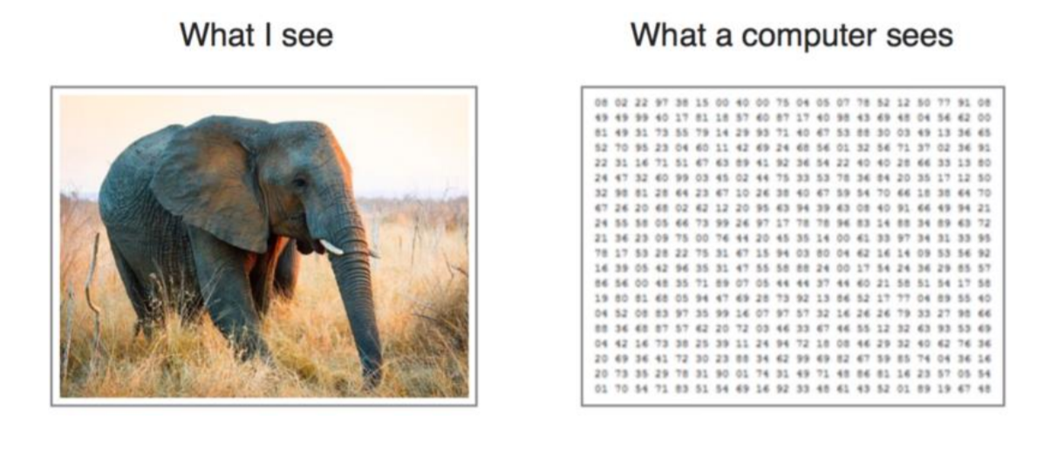

Figure 5 1: Computer Vision (Sorokina, 2017)

# Chapter 6 Image Processing

From the perspective of the computer, a picture is a huge rectangular cluster of pixel esteems. We will probably process at least one picture and to land at a choice for our application. Contingent upon the setting, it might be an arrangement issue, a bunching issue, or any of the other issue classes we have found in the book. The initial step will be to stack the picture from plate, where it is ordinarily put away in a picture explicit organization, for example, TIF, PNG or JPEG, the previous being a lossless pressure position and the last a lossy pressure, one that is enhanced for visual evaluation of photographs. Then, we may wish to perform preprocessing on the pictures (for instance, normalizing them for enlightenment varieties).

To make the workflow generalizable to others in the field, the researcher specifically chose to use the widely used image recognition algorithm Convolutional Neural Network (CNN). CNN is an altered assortment of profound neural net which relies on the relationship of adjacent pixels. It utilizes arbitrarily characterized patches for contribution toward the beginning and changes them in the preparation procedure. When preparing is done, the system utilizes these changed patches to anticipate and approve the outcome in the testing and approval process. Convolutional neural systems have made progress in the image classification issue, as the characterized idea of CNN matches the information point appropriation in the picture. Therefore, many picture handling errands adjust CNN for programmed highlight extraction. CNN is habitually utilized for medical image processing and picture segmentation too.

The design depends on the densely associated convolutional network (DenseNet), which comprise of dense blocks with layers that utilizes the pile of every single past layer as input, exchanged with transition blocks comprising of a 1×1 convolutional layer and 2×2 strided normal pooling. The CNN design has two fundamental sorts of change. The initial process is convolution, in which pixels are convolved with a filter or kernel. This progression gives the spot item between picture patch and kernel. The width and height of channels can be set by the network, and the depth of the channel is equivalent to the profundity of the information. A second significant change is subsampling, which can be of numerous kinds (max_pooling, min_pooling and average_pooling) and utilized according to prerequisite. The size of the pooling filter can be tunned by the user and is commonly taken in odd numbers. Here the dimensionality reduction of the data is entirely based on the pooling layer which indirectly help in reducing overfitting. Once the combination of convolution and pooling layers is completed the output is fed to an entirely connected layer for structured classification. CNN has an excellent architecture but what sets it apart is its simplicity to the user on the development. Also, CNN requires tremendous amount of data for training and consumes time while learning the data given and it also consumes more time as compared to the other supervised and unsupervised training algorithms.

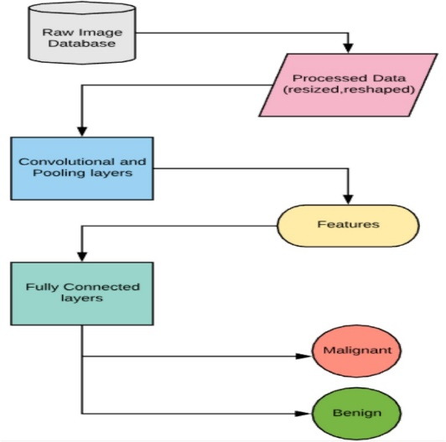 FIgure 6 1

# Chapter 7 PROPOSED METHOD

This proposal defines and surveys a Deep learning architecture for automized cancer detection that fuses ideas of computer vision, image classification and AI. We have depicted diverse Deep Neural Network models, particularly those adjusted to picture information, for example, Convolutional Neural Networks. This consists of the labelled (tumorous/non_tumorous) input image from the raw pixels and featured the visual examples, and afterward use those examples to recognize non-cancerous and malignant growth containing tissue, working likened to computerized recoloring, which spotlights picture sections critical for indicative choices, with the assistance of a classifier organize. The CNN was trained utilizing balanced dataset of 10,000 images in both classifications .i.e. tumor and non-tumorous.

Figure 7 1

Methodology is further explained in detailed by dividing into several step by step procedures:

## 7.1 Image processing

Most of the pixels in the picture are repetitive and don't contribute considerably to the inherent data. While managing AI systems, it is required to dispense with them to stay away from pointless computational overhead. This can be accomplished by pressure systems. We start the execution of our profound net by handling the pictures in the dataset. This is accomplished with the assistance of the OpenCV library in Python. There are numerous different modules that can be utilized in this progression for example MATLAB or other picture preparing libraries or programming. This is important to expel repetition from the info information which just adds to the computational intricacy of the system without giving any huge upgrades in the outcome. The viewpoint proportion of the first slide is saved since both the measurements are diminished by a factor of 2, giving a picture which is 1/4 in area, that is of measurement 32×32 pixels.

## 7.2 Feature Extraction

Feature learning is an important step in the characterization procedure for both human and machine learning. An investigation has demonstrated that the human cerebrum is delicate to shapes, while computers are progressively sensitive to patterns and texture. Considering this reality, include learning is totally extraordinary for manual versus machine. In the visual setting, dangerous tumors will in general have huge and unpredictable cores or different atomic structures. The cytoplasm likewise experiences changes, wherein new structures show up, or typical structures vanish. Dangerous cells have a little cytoplasmic sum, every now and again with vacuoles. In this situation, the proportion of cytoplasm to core diminishes. These highlights are analyzed by specialists, or calculations are created to measure these highlights to computerize identification. This methodology is troublesome and loose as determination and measurement include different obscure blunders that are difficult to address. On account of regulate learning, we don't have to give these highlights expressly. For this situation pictures are bolstered to a design, for example, CNN, alongside its group as a name (tumor or non-tumor). From the programmed update of filter esteems in the preparation procedure, CNN can remove the computational features. To put it plainly, for a given architecture of CNN channels and their loads, are highlights that are utilized at the hour of testing for model assessment. In this methodology, CNN takes raw pixels of a picture and gives yield as educated channel loads. These loads serve contribution to the thick engineering of the profound neural system for conclusive expectation. In our proposed algorithm, the convolutional neural system is comprised of two kinds of layers:

* Convolutional Layers
* Pooling Layers

## 7.3 Classification

Sampling the data to get 50% of tumorous and 50% of non-tumorous images for unbiased classification results. The proposal consists of two dataframes where tumorous and non-tumorous images are balanced consisting of 85,000 images in both classes. This procedure also involves splitting the data with stratified sampling so that the same proportion of labels is maintained in test as well as validation. Hence, there is need of tuning the parameters while splitting the train and test data to stratify new dataframe.

# Chapter 8 What is Fastai?

Fastai is a software library that is built on pytorch. It is compatible to many latest advancements in deep learning research, this library includes several pretrained model from torchvision, namely:

* resnet18, resnet34, resnet50, resnet101, resnet152
* squeezenet1_0, squeezenet1_1
* densenet121, densenet169, densenet201, densenet161
* vgg16_bn, vgg19_bn
* alexnet

This proposal trains and test the PCam dataset by building a deep neural network model using fastai library. The entire aim of the proposal is based on accurate ROC and AUC as well as the time taken by both computer vision (CNN) model and fastai.

Fastai is newly introduced python library which carries out AI-related tasks with its deep learning library for python. Fastai reduces the time and computation power required for training a deep learning algorithm. Based on top of pytorch, fastai contains some of the most popular algorithms for image classification and natural language tasks. This means that models can be created and run in just a few lines of code.

Inventor of fastai Jeremy Howard and Rachel Thomas says that “Fastai is the first deep learning library to provide a single consistent interface to all the most commonly used deep learning applications for vision, text, tabular data, time series, and collaborative filtering.

This is important for practitioners because it means if you’ve learnt to create practical computer vision models with Fastai, then you can use the same approach to create natural language processing (NLP) models or any of the other types of models we support.”

# Chapter 9 Model Implementation

## 9.1 CODE EXECUTED BY:

## 9.1.1 Importing required libraries:

The libraries used in the algorithm are: Tensorflow, keras, numpy, itertools, shutil, re, sci-kit learn, os, matplotlib, pandas

## 9.1.2 Reading the entire image data:

The main purpose of using python programming language in this proposal is because python has a special ability of parallel programming. The term parallel programming here means that the labelled image data is read simultaneously along with its .csv file which has labelled address of each image. This dataset contains 2,20,000 images which are labelled ‘0’ for “not_tumor” and ‘1’ for “tumor” with extension .tif .

* Id: Indicates the name of the image (in .tif format)
* Label ‘1’: Indicates ‘tumor’
* Label ‘0’: Indicates ‘not tumor’

## 9.1.3 Balanced classes are achieved by testing the image data and splitting into train and validation:

In this stage the data is sampled to get 50% of tumorous and 50% of non-tumorous images for unbiased classification result. Majorly focusing on balancing the classes the training data is divided into equal number of 10,000 samples in train and validation folder.

## 9.1.4 Fragmenting the data by creating 2 different dictionaries:

In this step image data augmentation and train/test process is made easy by creating two new train and validation dictionaries and separating data from the original train data so that the original image data stays unaffected .i.e. 10,000 labelled images are classified into tumor and not_tumor classes.

## 9.1.5 Data augmentation and conversion into tensors:

The data was augmented by the following features:

* Rescaling by a factor of 255.
* Rotating it by 40 degrees.
* Scaling the width by 20%
* Scaling the height by 20%
* Shear angle in counter-clockwise direction in degrees.
* Zoomed by 20%
* Flipping the image horizontally

## 9.1.6 Move the trained, tested and validated data to the suitable folders:

After creating the directories for the train, test and validation, the images are moved in the appropriate folders.

## 9.1.7 Model compilation and training:

The rough structure of the model is adapted from

- <https://github.com/shettyprithvi/Cancer-detection-image-classification-Convnet>

- <https://www.kaggle.com/fmarazzi/baseline-keras-cnn-roc-fast-10min-0-925-lb>

- <https://www.kaggle.com/vbookshelf/cnn-how-to-use-160-000-images-without-crashing>

* **Dropout:** 25% used after every Convolutional layer to avoid overfitting.
* **Activation:** Rectified Linear Unit (for every Convolutional layer)
* **Pooling used:** Maxpooling2D to select the maximum of the image feature maps.
* **Output layer:** The output layer used is softmax for this problem to get the probabilistic values of each class.
* **Convolution layer size:** 32, 64 and 128

The model is compiled with Adam’s optimizer for weight optimization (Learning rate of 0.0001 and decay rate of 10^-6. The decay rate ensures that the learning rate decreases over time as the training progresses.)

* **The loss used is:** Binary_crossentropy as there are two classes to be predicted.
* **Epochs:** The training goes for 3 epochs and checkpoint ensures that the model is saved which has the best accuracy overall.
* Prediction on test set images:
* Final test accuracy : 87.46%
* ROC score: 0.958
* Final F1-score : 87%

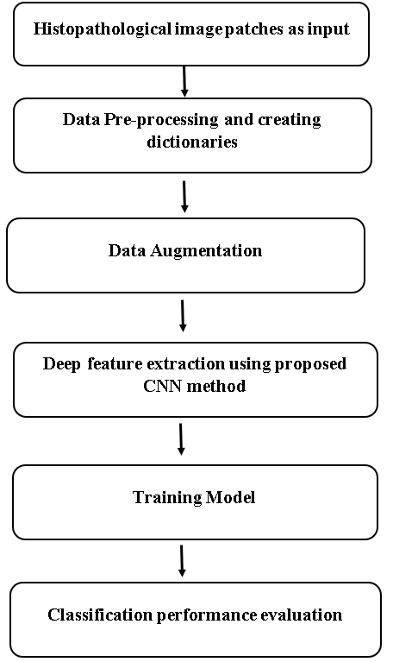

Figure 9 1

# Chapter 10 CONCLUSION

This proposal concludes that separating non-tumorous cases from harmful lesions is one of the difficulties of bosom malignancy. In this research, we propose a CNN and fastai model to contemplate the two-overlap material ness of CNN to improve the histopathological cancer determination. The structure proposed is a basic, productive and compelling framework for histopathology picture programmed examination. We effectively move ImageNet information as profound convolutional initiation highlights to the arrangement what's more, division of histopathology pictures with small preparing information. CNN highlights are fundamentally progressively incredible than master planned highlights. One commitment of this research is to examine the upsides of recombined pictures from PCam dataset in helping the finding of tumorous and non-tumorous cells utilizing a Deep-CNN and Fast Ai strategy. CNN is promising imaging methodology furnishing data and fast Ai believes in delivering fast results with more accuracy. Utilizing the condition of-workmanship prepared DeepNet as an element generator for grouping demonstrating, our investigation shows the highlights from cancerous images can accomplish precision of 0.80 and AUC of 0.88, including the recombined imaging highlights, fastai model execution improves to exactness of 0.89 with AUC of 0.91. This the principal concentrate to build up a layered CNN to find accurate results. Based on the outcomes acquired in this work, the Deep Learning approach, especially utilizing pretrained CNNs as highlight extractors, is a promising technique while tending to the issue of diagnosing histopathological cancer pictures. Since in this setting the dependability of the framework is profoundly applicable, it is attractive to expand the accomplished 64.52% test precision. This result could be improved by trimming the picture to a particular ROI in which a tumor could be found; through adjusting of the last layers or preparing the entire system parameters. The aftereffects of extra tests utilizing a subset of the Caltech-101 database, for which a 99.38% test precision was gotten, show the pertinence of the likeness between the information used to prepare the model and the specific application proposed. Also, it is important the effect of the information expansion process also, the parity of the quantity of models per class on the execution of the framework.

**FUTURE WORK**

 While promising, there is space for future work. As a matter of first importance, the prepared DeepNet is a discovery highlight generator, the highlights extricated may not be anything but difficult to be deciphered by the doctors. It is our aim to find conceivable clinical translations from the highlights as one of our future assignments. For instance, as the DeepNet goes further, the underlying layers of the highlights may speak to the crude imaging attributes as the primary request insights, the more profound layer of the highlights may speak to the morphological qualities (e.g., shape). This is yet to be investigated. A subsequent future work is connected to the fix sizes. This research intends to evaluate effects of the distinctive estimated patches for both info and yield pictures on the histopathological malignant growth determination.   
Future research could also be centred around the assessment of the following methods:  
To extricate highlights from various layers of the CNN rather than just utilizing the initiations acquired from the last convolutional layer. To utilize distinctive pretrained CNNs as highlight extractors, for example GoogleNet and ResNet. To test other classifier structures: neural systems, fuzzy inference systems or clustering techniques.

**BIBLIOGRAPHY**

[Dspace.cc.tut.fi](http://dspace.cc.tut.fi/).(2020).[online] Available at: <https://dspace.cc.tut.fi/dpub/bitstream/handle/123456789/26160/Khorrami.pdf?sequence=3&isAllowed=y> [Accessed 6 Jan. 2020].

Babakint.com. (2020). [online] Available at: <http://www.babakint.com/files/thesis-compressed.pdf> [Accessed 6 Jan. 2020].

[Barisgecer.github.io](http://barisgecer.github.io/). (2020). [online] Available at: <https://barisgecer.github.io/files/gecer_thesis-compressed.pdf> [Accessed 6 Jan. 2020].

[Inf.ufpr.br](http://inf.ufpr.br/). (2020). [online] Available at: <http://www.inf.ufpr.br/lesoliveira/download/TeseFabioSpanhol.pdf> [Accessed 6 Jan. 2020].

Arxiv.org. (2020). [online] Available at: <https://arxiv.org/ftp/arxiv/papers/1811/1811.04241.pdf> [Accessed 6 Jan. 2020].

[Homes.cs.washington.edu](http://homes.cs.washington.edu/). (2020). [online] Available at: <https://homes.cs.washington.edu/~shapiro/selim_breast_2018.pdf> [Accessed 6 Jan. 2020].

[Scholar.google.com](http://scholar.google.com/). (2020). [online] Available at: <http://scholar.google.com/scholar_url?url=https://pdfs.semanticscholar.org/342c/e4663b1cbe2a1ca2f0e85bd362a3432635b8.pdf&hl=en&sa=X&scisig=AAGBfm0mhV7Gqkm20yCnIYD68JcZ4SL5eA&nossl=1&oi=scholarr> [Accessed 6 Jan. 2020].

[Citeseerx.ist.psu.edu](http://citeseerx.ist.psu.edu/). (2020). [online] Available at: <http://citeseerx.ist.psu.edu/viewdoc/download?doi=10.1.1.366.2124&rep=rep1&type=pdf> [Accessed 6 Jan. 2020].

Al-Zubaidi, L. (2020). *Deep learning based nuclei detection for quantitative histopathology image analysis*. [online] [Mospace.umsystem.edu](http://mospace.umsystem.edu/). Available at: <https://mospace.umsystem.edu/xmlui/handle/10355/59855> [Accessed 6 Jan. 2020].

[Ieeexplore.ieee.org](http://ieeexplore.ieee.org/). (2020). *Multiple clustered instance learning for histopathology cancer image classification, segmentation and clustering - IEEE Conference Publication*. [online] Available at: <https://ieeexplore.ieee.org/abstract/document/6247772> [Accessed 6 Jan. 2020].

Åstrand, A., Jalkanen, V., Andersson, B. and Lindahl, O. (2020). *Detection of stiff nodules embedded in soft tissue phantoms, mimicking cancer tumours, using a tactile resonance sensor*. [online] DIVA. Available at: <http://www.diva-portal.org/smash/record.jsf?pid=diva2%3A698322&dswid=-1713> [Accessed 6 Jan. 2020].

Kårsnäs, A. (2020). *Image Analysis Methods and Tools for Digital Histopathology Applications Relevant to Breast Cancer Diagnosis*. [online] DIVA. Available at: <http://www.diva-portal.org/smash/record.jsf?pid=diva2%3A699154&dswid=mainwindow> [Accessed 6 Jan. 2020].

Basavanhally, A. (2020). *Automated image-based detection and grading of lymphocytic infiltration in breast cancer histopathology*. [online] [Rucore.libraries.rutgers.edu](http://rucore.libraries.rutgers.edu/). Available at: <https://rucore.libraries.rutgers.edu/rutgers-lib/26510/> [Accessed 6 Jan. 2020].

[Citeseerx.ist.psu.edu](http://citeseerx.ist.psu.edu/). (2020). [online] Available at: <http://citeseerx.ist.psu.edu/viewdoc/download?doi=10.1.1.389.5203&rep=rep1&type=pdf> [Accessed 6 Jan. 2020].

[Ieeexplore.ieee.org](http://ieeexplore.ieee.org/). (2020). *Histological Image Feature Mining Reveals Emergent Diagnostic Properties for Renal Cancer - IEEE Conference Publication*. [online] Available at: <https://ieeexplore.ieee.org/abstract/document/6120479> [Accessed 6 Jan. 2020].

[Ieeexplore.ieee.org](http://ieeexplore.ieee.org/). (2020). *Automated Breast Ultrasound Lesions Detection Using Convolutional Neural Networks - IEEE Journals & Magazine*. [online] Available at: <https://ieeexplore.ieee.org/abstract/document/8003418> [Accessed 6 Jan. 2020].

[Ieeexplore.ieee.org](http://ieeexplore.ieee.org/). (2020). *Breast cancer histopathological image classification using Convolutional Neural Networks - IEEE Conference Publication*. [online] Available at: <https://ieeexplore.ieee.org/abstract/document/7727519> [Accessed 6 Jan. 2020].

Geras, K., Wolfson, S., Shen, Y., Wu, N., Kim, S., Kim, E., Heacock, L., Parikh, U., Moy, L. and Cho, K. (2020). *High-Resolution Breast Cancer Screening with Multi-View Deep Convolutional Neural Networks*. [online] arXiv.org. Available at: <https://arxiv.org/abs/1703.07047> [Accessed 6 Jan. 2020].

Deep Learning Course Forums. (2020). *Breast cancer classification with deep learning*. [online] Available at: <https://forums.fast.ai/t/breast-cancer-classification-with-deep-learning/45224> [Accessed 6 Jan. 2020].

Anon, (2020). [online] Available at: <https://www.researchgate.net/publication/332776640_Detection_of_Breast_Cancer_Using_Infrared_Thermography_and_Deep_Neural_Networks> [Accessed 6 Jan. 2020].

Worldscientific.com. (2020). *A DEEP LEARNING APPROACH FOR CANCER DETECTION AND RELEVANT GENE IDENTIFICATION | Biocomputing 2017*. [online] Available at: <https://www.worldscientific.com/doi/abs/10.1142/9789813207813_0022> [Accessed 6 Jan. 2020].

RESULTS :

DISCUSSION :

APPENDIX :